Project The Bet: the metals index
By
Ayomide Fatogun

Contents
Introduction 3
The Issue 3
The Methodology of the Bet 4
Results. 5
The Relevance Then / The Relevance Now 6
The Relevance Then (1980–1990) 6
The Relevance Now (2025) 7
VI. Concluding Comments 7
References 9

Introduction
In 1980, economist Julian Simon and biologist Paul Ehrlich placed a public wager reflecting their differing opinions on resource scarcity. Ehrlich, concerned about fast population expansion and environmental degradation, predicted that critical raw commodities would become scarcer and more expensive over time. Simon disagreed, claiming that human inventiveness and market forces will increase resource availability and cut costs. To put their hypotheses to the test, they bet on the future prices of five metals: tungsten, copper, chromium, nickel, and tin for 10 years. This bet became a historic point in discussions about demographic, environmental, and economic sustainability.

The Issue
The Simon-Ehrlich bet revolved around an essential dispute regarding the future of Earth's resources in the face of rising population increase. Paul Ehrlich thought that as the world's population grew, natural resources would become increasingly scarce, resulting in soaring commodity prices, starvation, and ecological catastrophe. His beliefs were based on the Malthusian theory that population increase will surpass the planet's ability to generate food and raw minerals.
However, Julian Simon questioned this pessimism. He maintained that humans are more than simply resource consumers; they are also solution providers. He believed that scarcity would encourage invention, substitutes, and efficiency, driving real resource costs to shrink over time. Simon regarded free markets and technological advancement as powerful forces capable of meeting human needs despite increasing numbers of people.
This conflict between environmental restrictions and economic optimism posed crucial problems. Are natural resources really limited? Can markets and creativity overcome environmental challenges? The bet was an attempt to base this discussion in real-world facts and determine if prices, which are employed as scarce signals, would climb or decline over a decade of global changes.

The Methodology of the Bet
Julian Simon presented a simple challenge: Paul Ehrlich may select $1,000 worth of any sort of raw material in 1980 that he predicted would rise in inflation-adjusted price by 1990. Ehrlich chose five metals: tungsten, copper, chromium, nickel, and tin, assuming that resource decline would lead their prices to rise. Simon predicted that human inventiveness and market forces will bring down prices.
After 10 years, both parties would compare the true prices of the same quantities of metals. If the entire price had increased, Simon would pay Ehrlich the variation in price. If it decreases, Ehrlich will compensate Simon.
To illustrate the data, we created a Simple Real Price Index by normalizing the metals' average price in 1980 as the base year. The index measures price fluctuation over time.
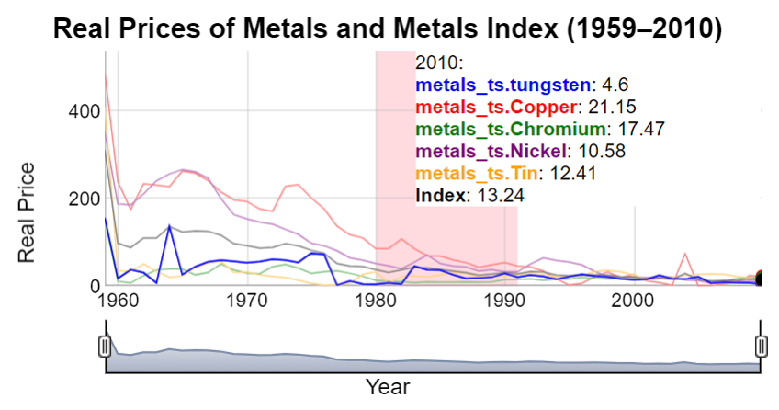
Results.
Using historical pricing data for tungsten, copper, chromium, nickel, and tin, inflation-adjusted prices were calculated and displayed over time. Between 1980 and 1990, the real price indexes for each metal showed a decline. This supported Simon's theory that market forces, technical breakthroughs, and increased efficiency would result in reduced resource prices despite rising global demand.
The graph highlights the bet period, clearly demonstrated that all five metals saw genuine price declines. Therefore, Ehrlich lost the bet and paid Simon the agreed-upon amount.
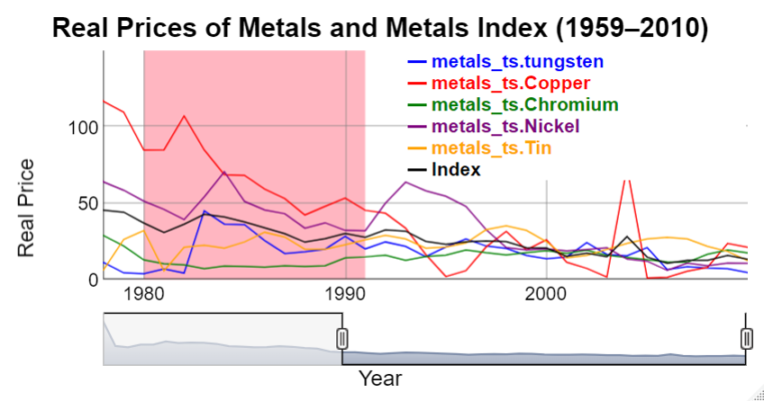

The Relevance Then / The Relevance Now

The Relevance Then (1980–1990)
In the early 1980s, the world was experiencing economic uncertainty, post-oil shock inflation, and heated environmental debates. The Simon-Ehrlich gamble occurred against the backdrop of uncertainty (Wiki, 2025)
Ehrlich predicted that increasing population expansion will increase demand for scarce resources, driving up costs. His ideas were based on ecological restrictions and Malthusian reasoning.
Simon's Position: He contended that markets, via price signals, would stimulate innovation and substitution, therefore keeping resources ample and prices reasonable.
The price index we visualized (see the graph above) visibly verifies Simon's perspective.
This drop represented not just the availability of resources, but also technological adaptability and market dynamics, which validated Simon's market-based argument at the time.

The Relevance Now (2025)
In 2025, the Simon-Ehrlich issue is still significant but is currently evolving. While breakthroughs in mining, recycling, and replacement have justified Simon's optimism in innovation by keeping many commodity prices under control, Ehrlich's warnings about ecological limitations now dominate world discourse. The renewable energy revolution has increased demand for essential minerals such as lithium and cobalt, resulting in price surges and new supply threats (Home, 2022).
At the same time, increased worldwide consumption and global warming have pushed ecosystems to their limits. Resource depletion is no longer about running out, but rather about how exploitation hurts the ecosystem.
In sum, Simon won the price gamble, but Ehrlich's wider worries about sustainability are becoming increasingly pertinent now.

VI. Concluding Comments
The Simon-Ehrlich Bet remains an important point in the debate over confidence in the economy and environmental prudence. While Julian Simon won on commodities pricing, Paul Ehrlich's broader concerns about resource scarcity and ecological stress became more urgent in 2025.
The US government should prioritize harmonizing innovation with sustainability. This includes investing in green technologies, improving supply networks for vital minerals, and implementing environmental legislation that prioritizes long-term ecological health above short-term economic benefit.
Finally, the lesson is clear: prices can fall, but no market can restore ecosystems that have collapsed.

References
Home, A. (2022, December 12). Lithium still super-charged as supply chases after demand | Reuters. https://www.reuters.com/markets/commodities/lithium-still-super-charged-supply-chases-after-demand-2022-12-15/
Wikimedia Foundation. (2025, March 19). Early 1980s recession. Wikipedia. https://en.wikipedia.org/wiki/Early_1980s_recession

